# Stowaway Tunbridge Wells

# High Weald of Kent and Sussex Tour

6th – 10th July 2025 five days, four nights.

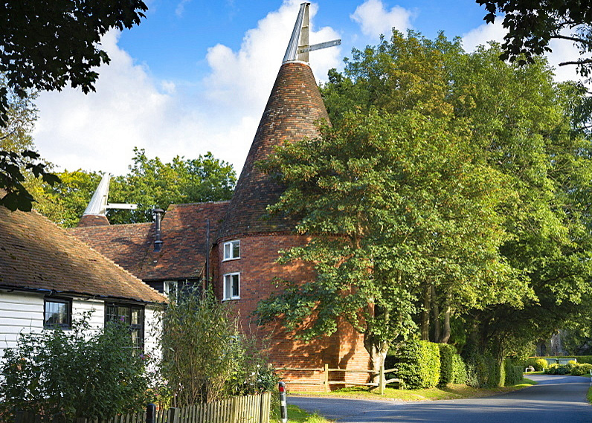

Kentish Oast House

Our High Weald Tour

Based at The Spa Hotel Tunbridge Wells, this area of the High Weald is rich in historic places and gardens, scenic lanes and an ideal base to explore the many National Trust locations in the area.

Tunbridge Wells lies in the beautiful Kent countryside where Oast Houses, leafy woodland scenic lanes and orchards all feature prominently. It was one of the most fashionable spa towns of Georgian England and the elegance of this bygone era remains today in what is now the only spa town in Southeast. If you don’t know the area at all then the funny looking houses with the conical roofs are Oast Houses, originally used for brewing beer but mostly now used as domestic residences.

A paradise for history, and especially garden lovers, this corner of Kent/Sussex has more castles, stately homes and gardens open to the public concentrated in it than any other area of the UK.

brief tour overview…

A five-day tour based around the Kent and Sussex Weald known for its world-famous gardens, fairy-tale moated castles and mellow country manors, the romantic moat-ringed Scotney Castle and the Sissinghurst Castle Gardens. Historic locations as Chartwell (the home of Winston Churchill) and Hever Castle, home of Anne Boleyn and later Henry’s fourth wife, Anne of Cleves.

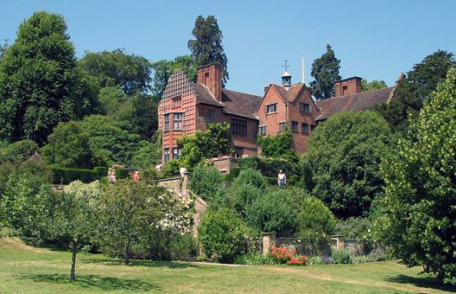

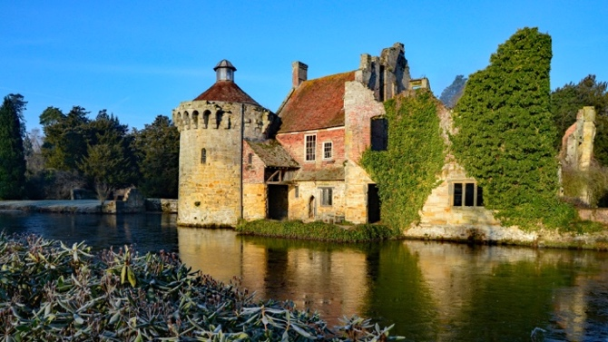

Scotney Castle Chartwell House

We have three timed events: a private tour of Winston Churchill’s home Chartwell where we have access before the public are admitted; a private guided tour of Hever Castle with access to the Gardens has been arranged for our group, and on the last day a visit Balfour Winery is one of England’s leading wine producers for a self-tutored tasting and the option to have a light lunch and a drink in their restaurant. On our last evening, prior to dinner, we have light entertainment provided by the Merry Opera Group.

You also have options to visit many other locations at your leisure and of course to add in any that you particularly want to visit or spend half a day just exploring the historic town of Tunbridge Wells.

Options on our routes to Bedgebury National Pinetum and Forest, Bewl Water Reservoir, Penshurst Place, Salomons Estate, NT Chiddingstone Village, Tunbridge Wells Pantiles, Kew Gardens at Wakefield Place, Scotney Castle and Sissinghurst Gardens. Walking options available at some of the locations.

## We have planned three optional runs that are the most scenic (but not necessarily the most direct). The first to Chartwell House and then onto Wakefield Place, the second to Hever Castle then onto Scotney Castle and Gardens and nearby Bedgebury Pinetum and the last run is to Sissinghurst Castle and Gardens plus Balfour Winery wine tasting all via scenic Kentish hop villages.

The Spa Hotel is withing walking distance from the Pantiles, set in 14 acres of picturesque grounds, ample parking, an indoor swimming pool, an award-winning restaurant as well as our contemporary whilst taking advantage of easy access to historic Tunbridge Wells and the beautiful Kent countryside.

Our comprehensive tour book ensures that you will not miss out on places of scenic or historical interest.

We don’t like large groups! Accordingly, we would advise an early booking if this is of interest.

This organised and hosted tour is probably the last Lyn, and I will do as time is catching up with us.

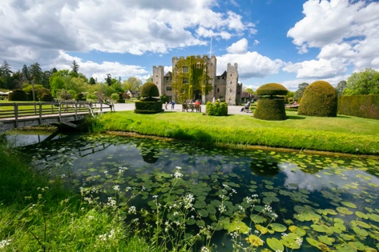 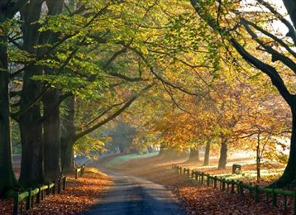 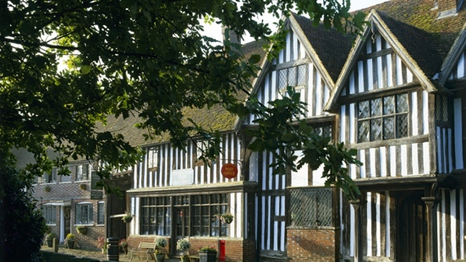

Hever Castle -Typical Lane - Chiddingstone NT Village.

itinerary …

Sunday 6th July 2025

17:00 Check-in from three pm.

19:00 Welcome drinks and briefing in the Lobby.

19:30 Dinner in the Orangery for Dinner.

Monday 7th July 2025

8:00 Breakfast in the Orangery.

9:00 Leave for Chartwell Run.

9:45 Chartwell private tour.

11:30 Continue suggested run to Wakefield Place.

19:00 Dinner in the Orangery.

Tuesday 8th 2025

8:30 Breakfast in the Orangery

9:45 Leave for Hever Castle Run.

## 10:30 Hever Castle private tour and entrance to the gardens.

## Scotney Castle and Gardens, Bedgebury Pinetum via scenic Kentish hop villages.

19:00 Dinner in the Orangery.

Wednesday 9th 2025

8:30 Breakfast in the Orangery

9:30 Run: Sissinghurst Gardens, Balfour Winery wine tasting and tour.

19:00 The Merry Opera company fun cabaret entertainment, Queens Room.

19:45 Private dinner in the Queens Room.

Thursday 10th 2025

8:30 Breakfast.  
10:30 Check-out by 10:30

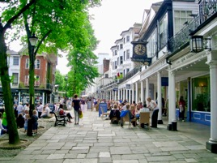 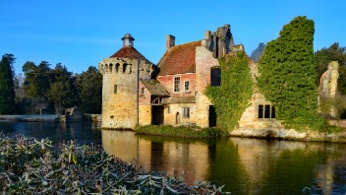

Tunbridge Wells Pantiles Scotney Castle

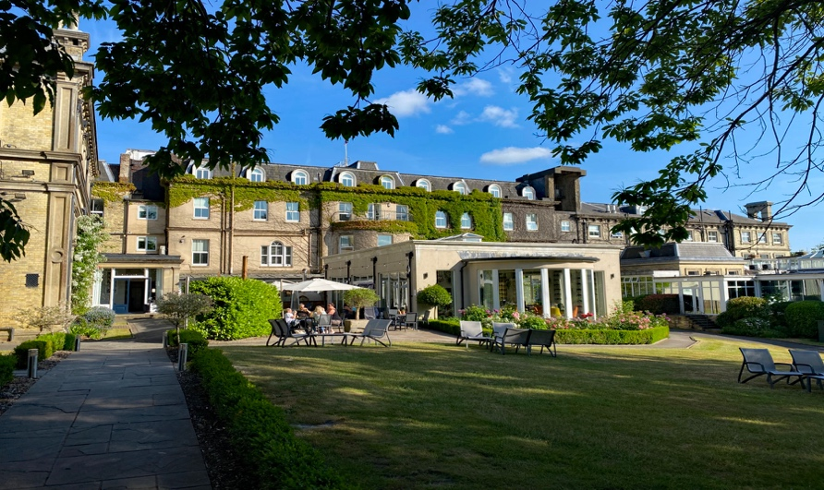day one...

Sunday 6th July Check-in

Check-in from three pm, we have our parking area.

Welcome drinks and briefing in the lobby.

Dinner in the Orangery.

day two...  
Monday 7th July Chartwell Run

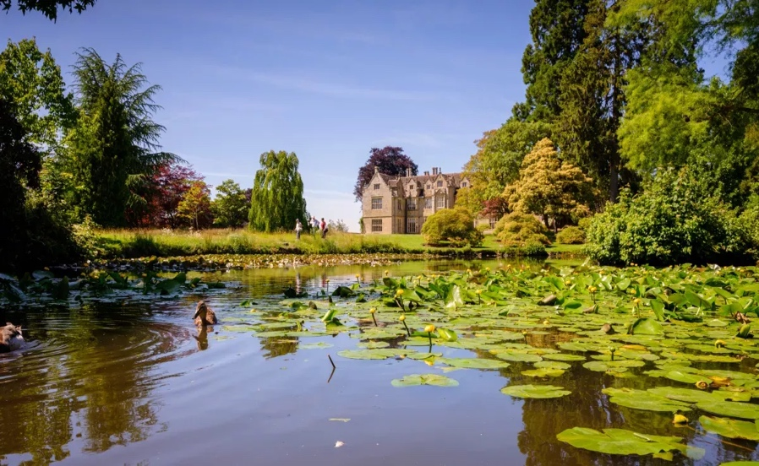The 30 minutes scenic drive to Chartwell for a private tour of the house before it opens to the public at 09:45. Winston and Clementine Churchill bought Chartwell in 1922; it would be their family home for the next forty years. Here Churchill was a politician and statesman but also a husband, father, writer, painter and garden planner. The rooms in the house remain much as they were when he lived here, with pictures, books and personal mementoes while a special exhibition gives deeper insight into his life through 50 objects. Chartwell’s hillside gardens reflect his love of landscape and nature. Landemare Café for coffee and snack after the tour.

The run continues to Wakefield Place where you enter via the welcoming Visitor Centre. It is an interesting shopping area, and some nice and unusual plants can be purchased from the gardens. Within the Visitor Centre is 'The Seed Cafe' Leave the Visitor Centre to reach the Millennium Seed Bank which displays interesting information and photos.

Even if Wakefield Place is not of interest the 55-mile scenic drive avoids any suburban areas.

Back to the hotel then if you’ve got the time perhaps take the short walk down the Pantiles or Tunbridge Wells centre or perhaps a swim in the indoor swimming pool or indulge in a spa treatment.

Perhaps meet up in the Zagatos Bar for a pre-dinner chat and drinks then dinner in the Orangery at 19:00.

day three...

Tuesday 8th  July Hever Run - Bedgebury - Scotney Castle – Bewl Water

~~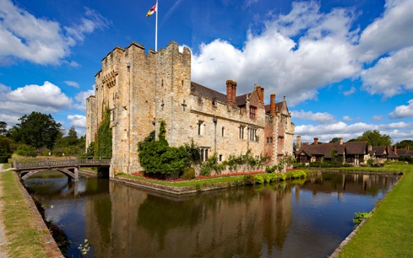~~

Hever Castle and Gardens

We take you half an hour scenic route via Kentish hop villages and Chiddingstone NT village to Hever Castle for our private tour of the Castle which starts at 10:30 that then gives access to the gardens. We tour of the castle with an experienced and highly knowledgeable guide.

Experience over 600 years of history at the romantic double-moated 14th century castle once the home of Anne Boleyn, second wife of Henry VIII and mother of Elizabeth I.

Discover magnificent award-winning gardens set in 125 acres of glorious grounds.

Discover the Miniature Model Houses, which can be accessed via the Hever Shop.

Bedgebury Pinetum

Bedgebury National Pinetum & Forest: Bedgebury is in the High Weald of Kent, contains the world's leading collection of conifers and is a beautiful setting for walks. Visitor Centre has a café with light meals.

Scotney Castle is an interesting house and medieval castle ruins set in a beautiful moat full of water lilies.

Bewl Water: Discover incredible landscapes, at the largest reservoir in the Southeast with miles of scenic pathways to walk, and hundreds of protected species to discover.

Bewl Water

Discover landscapes, native wildlife, and woodland adventures at the largest reservoir in the Southeast, 800-acre parkland is unlike anywhere else. With miles of scenic pathways to walk, and hundreds of protected species to discover. As nature haven the reservoir is as a refuge for wildlife. Some 3,000 species live on or around the water.

Hever Castle private tour and entrance to the gardens,

Bedgebury Pinetum, Scotney Castle and Gardens, via scenic Kentish hop villages.

Perhaps meet up in the Zagatos Bar for a pre-dinner chat and drinks then dinner in the Orangery at 19:00.

day four...

Wednesday 9th Sissinghurst Castle and Gardens - Balfour Winery

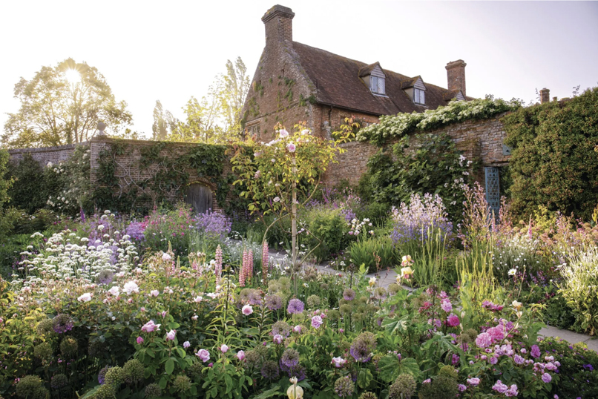

Sissinghurst Castle

Beautiful gardens around a Tudor Tower, take a tour of the cottage that Vita Sackville West lived in with her husband. Vita's writing room can be viewed at the top of the tower but the gardens are the star of the show.

~~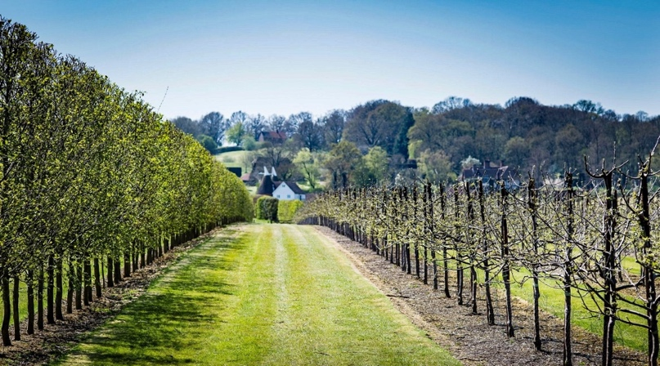 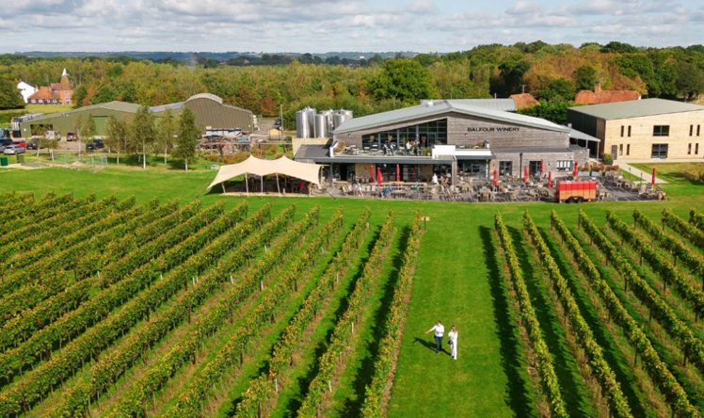~~

Balfour Winery

A 400-acre family-owned Tudor estate in the heart of the Kent countryside and is home to award-winning Balfour English Wine and Balfour Beers and Cider producers. The venue has nice ambience with interesting art and sculptures inside, with a good café. You can take the Self-Guided Vineyard Tour and explore the picturesque estate at your own pace. Self-tutoring tasting of three wines at 14:00. This scenic route of 50 miles via Kentish/Sussex hop villages. Back to the hotel and perhaps walk down the Pantiles or Tunbridge Wells centre which is short walk or choose a swim in the indoor swimming pool or indulge in a spa treatment.

The Merry Opera Company provides us with some light entertainment before dinner.

Run: via Kentish hop villages, Sissinghurst Gardens, Balfour Winery wine tasting and tour.

Balfour Winery self-tutoring tasting of wines, lunch option.

The Merry Opera Company fun cabaret entertainment

Private Dinner in the Queens Room.

day five...

Thursday 10th

8:30 Breakfast.  
10:30 Checkout by 10:30

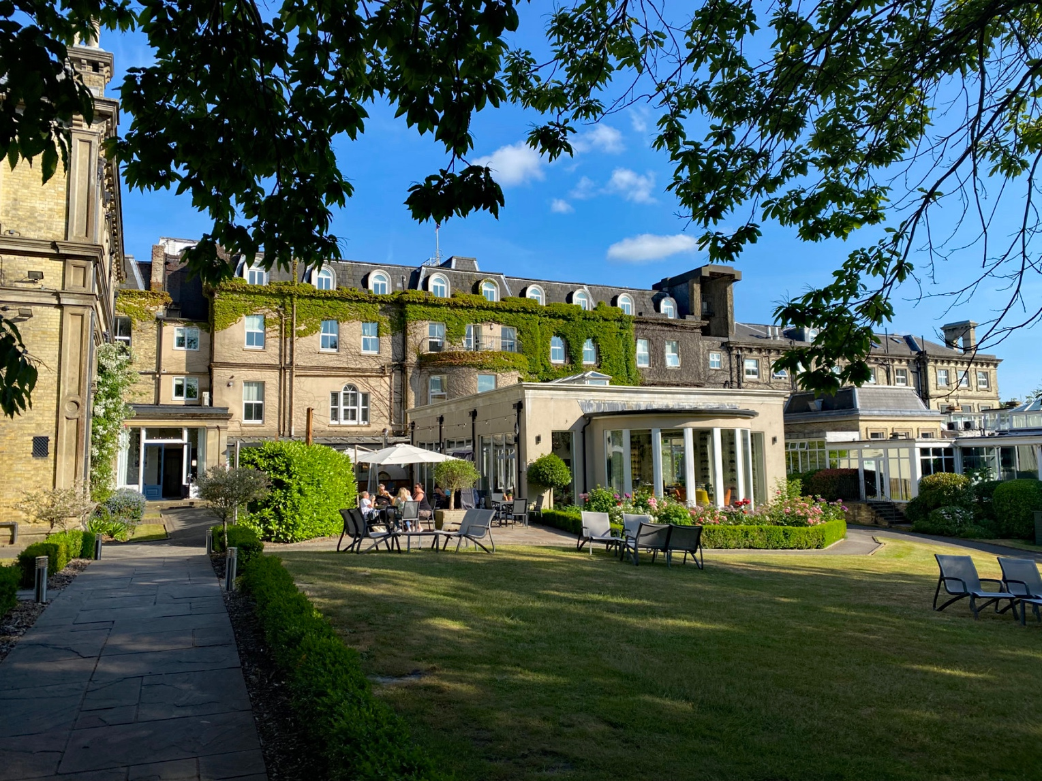

The Spa Hotel

Originally built in 1766 as a country mansion. Set in 14 acres of picturesque grounds close to the centre of Royal Tunbridge Wells, the spa town from which its name is derived.

The Spa Hotel has a long-established history in the town, ample parking, an indoor swimming pool and gyms, plus an award-winning restaurant as well as the contemporary Zagatos Bar. There is plenty for guests to enjoy whilst taking advantage of easy access to historic Tunbridge Wells and the beautiful Kent/Sussex countryside.

In keeping with the tradition of the town, Spa offers a range of heavenly treatments to make your visit even more relaxing. Indulge in one of the packages or simply make use of the pool and steam room, perfect for combining with Afternoon Tea in The Orangery Restaurant.

useful web links…

[Booking Tour:](https://www.drive-away.co.uk/interest-registration/) This link takes you direct to the online registration form.

[Tunbridge Wells:](https://www.visitsoutheastengland.com/places-to-visit/royal-tunbridge-wells-p196441)

The elegance and atmosphere of this bygone era remain today in this, the only spa town in Southeast England.

[Chartwell House](https://www.nationaltrust.org.uk/visit/kent/chartwell) : For over forty years it was the home of Sir Winston Churchill.

[Hever Castle and Gardens.](https://www.hevercastle.co.uk/) Home of Anne Boleyn.

## [Wakefield Place](https://www.kew.org/wakehurst) : House and botanic gardens, owned by the NT but used and managed by the Gardens, Kew.

[Hever Castle and Gardens:](https://www.hevercastle.co.uk/whats-on/hever-in-bloom/?gad_source=1&gclid=CjwKCAjwvvmzBhA2EiwAtHVrbxdAmNxGicjA7CslnpvK1T4LjA-_irg1FyH20ijRdfxvejVEiLuTZxoCxPsQAvD_BwE)  Hever Castle was once the childhood home of Anne Boleyn.   
During your visit you will discover award-winning gardens and a rich and varied history.

[Bedgebury Pinetum](https://www.forestryengland.uk/bedgebury): The National Pinetum is home to a world-leading collection of conifers.

[Balfour Winery:](https://balfourwinery.com/) For nature and wine lovers alike, enjoy a self-guided stroll through vineyards,

[Penshurst Place:](http://www.penshurstplace.com/) Once the property of King Henry VIII, was left to his son King Edward VI and granted Sir William Sidney in 1552. The Sidney family have been in continuous occupation for more than 470 years since.

Proud that it is still a family home, discover the charm of Penshurst in the State Rooms, Gardens.

[Scotney Castle:](http://www.nationaltrust.org.uk/visit/kent/scotney-castle) NT Country house with formal gardens in the valley of the River Bewl in Kent.

The gardens, which are a site of special scientific Interest and a celebrated example of the picturesque style.

[Sissinghurst Gardens:](https://www.greatbritishgardens.co.uk/kent/item/sissinghurst-castle-gardens.html) Sissinghurst Garden is one of the top 20 gardens in the British Isles.

[Scotney Castle:](https://en.wikipedia.org/wiki/Scotney_Castle) A country house, romantic garden, 14th century moated castle.

[Ashdown Forest:](https://ashdownforest.org/) Is one of the largest open access areas in Southeast England.  Situated within the High Weald Area of Outstanding Natural Beauty,

[Cranbrook](https://visittunbridgewells.com/plan-your-trip/towns-villages/cranbrook/): Known as the ‘Capital of the Weald’, is a pretty town with a medieval street layout.

[Salomons Estate](https://www.salomons-estate.com/)  Salomons Estate is a stunning Victorian mansion combining elegance and history.

[Bewl Water](https://www.bewlwater.co.uk/)  largest reservoir in the Southeast.

[Booking Tour:](https://www.drive-away.co.uk/interest-registration/) This link takes you direct to the online registration form.

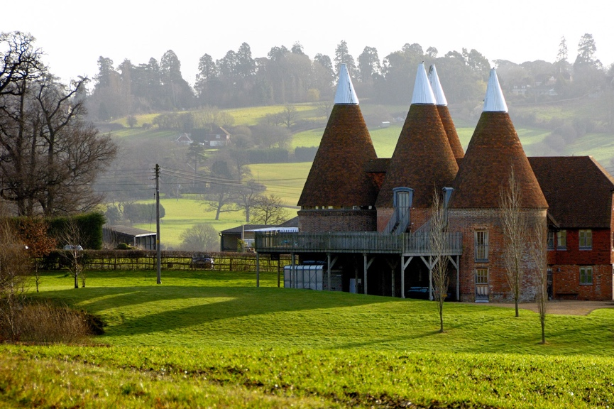 

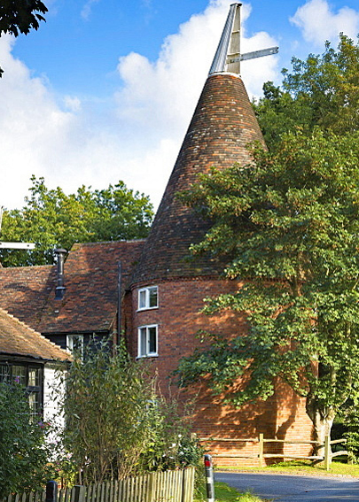

Tour details…

# Stowaway Tunbridge Wells High Weald of Kent and Sussex Tour

6th–10th July 2025 five days, four nights.

What’s included:

Accommodation.

Three course dinner every day.

Breakfast.

Free parking area.

Private tour Chartwell House.

Hever Castle private tour.

Group dinning.

Reception Drink.

Balfour Winery wine tasting.

Three optional driving runs.

Comprehensive tour book.

The Merry Opera Company fun cabaret.

Hosted by Paul and Lyn Trill.

What's Not Included:

Entry costs other than Chartwell and Hever.  
All drinks to allow for individual choices.  
Parking Cost at any visited venue.

Tour Cost:

£975.00pp cost is based on two people sharing a room.

Contact:

Telephone: +44 (0) 1243 942100 Email: [paul@drive-away.co.uk](mailto:paul@drive-away.co.uk)

Note: we reserve the right to amend the dates, rates and itinerary in this brochure